Young Li

A13750891

Ying (Patrick) Pei

A13595990

Lab: (Monday 7-10PM A55)

Lab Room: WLH-2215

ECE 35 Lab 2 Report

**Introduction**

The objective of this project is to analyze, build, and test a 4-bit Digital to Analog Converter (DAC) based on an R/2R ladder network. DACs and their twin brother, ADCs are core components for any electronics with a microprocessor brain. Digital Cameras have a sensor behind the lens collects brightness and color information. These are analog signals that are subsequently converted to binary numbers via ADC for the processor to compute and record to the memory card. In the back of the camera, a DAC will read each digital input and restore them to corresponding analog levels to power each pixel on the LCD display with correct brightness and color.

**Procedure**

**Prelab part**

* We are given a circuit in the Analysis portion of the lab. (Figure 1)
* We are told to solve this circuit and find the value of Vout.
* We have to find Vout before beginning the lab.

**Setting up the counter chip**

* The first step we took was wiring the counter chip. (Figure 2)
* We connected the function generator to the clock input(pin 15).
* The function generator is set to provide a 0 to 5V square wave at a frequency of 10KHz.
* We powered Vdd and UP/DOWN (pins 16 and 10 respectively) with 5V from the power supply.
* We grounded pins 1, 5, 8, and 9.
* The P1 – P4 (pins 3, 4, 12, and 13) are left unconnected.
* The rest of the pins are Q1 through Q4 which is our power supply sources.

**Testing the Counter Chip**

* Now, we have to test the counter chip.
* We set up the oscilloscope and connect to certain pins to check the frequency.
* First, we test pin 15 which is our clock. This should read a frequency of 10KHz.
* We have to record the data from the oscilloscope and write it down.
* Now, we repeat for all Q1 through Q4. (Data will be in the Analysis section)
* A common theme should be that the frequency should be halved each time.
* If that is not the case, the wiring is off or wrong and should be checked.
* We must record all the data like how we did for the clock, and show the peak to peak voltage and frequency.
* Next we have to test it with the logic analyzer.
* Hook the grey lead of the logic analyzer to ground, the black lead to the clock, the brown lead to the Q1, the red lead to the Q2, and the orange lead to Q3, the yellow lead to Q4.
* If one of the leads happen to be broken, you can substitute another color for another.
* We have to connect the USB to the computer and open up the logic program.
* We press start at the top and we received a diagram shown below.
* After verifying that the logic analyzer graphs look like the picture in the lab report, we have successfully verified that the counter chip is working properly.

**Building the Ladder Network**

* Now we can build the Ladder Network.
* We start off by gathering eleven 100kOhm resistors.
* 50kOhms resistors are created by putting two 100kOhm resistors in parallel.
* For the voltage sources, we just use Q1-Q4.
* We connect it to the O-Scope and expect to see a ladder network.
* We have to save the picture and show the ladder network in our analysis.

**Circuit Diagrams and Pictures**

Figure 1. Circuit Diagram

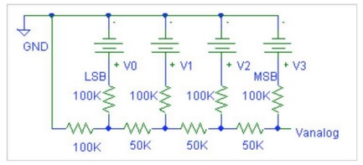

Figure 2. Counter Chip Diagram

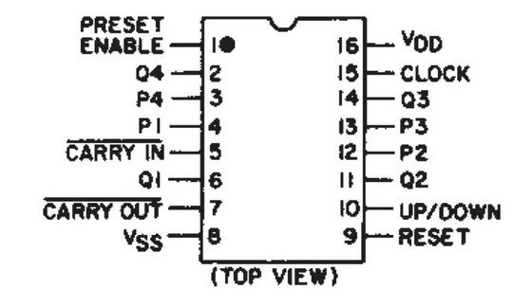

Figure 3. Logic Analyzer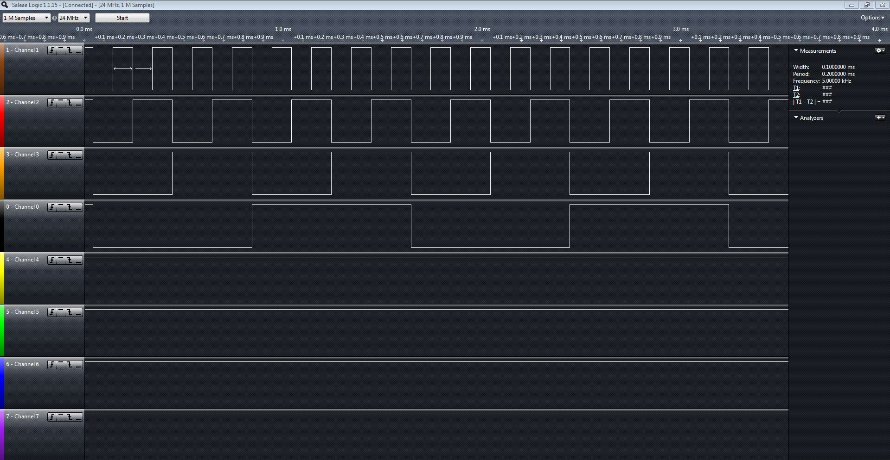

Figure 4. Ladder Resistor graph (blue)

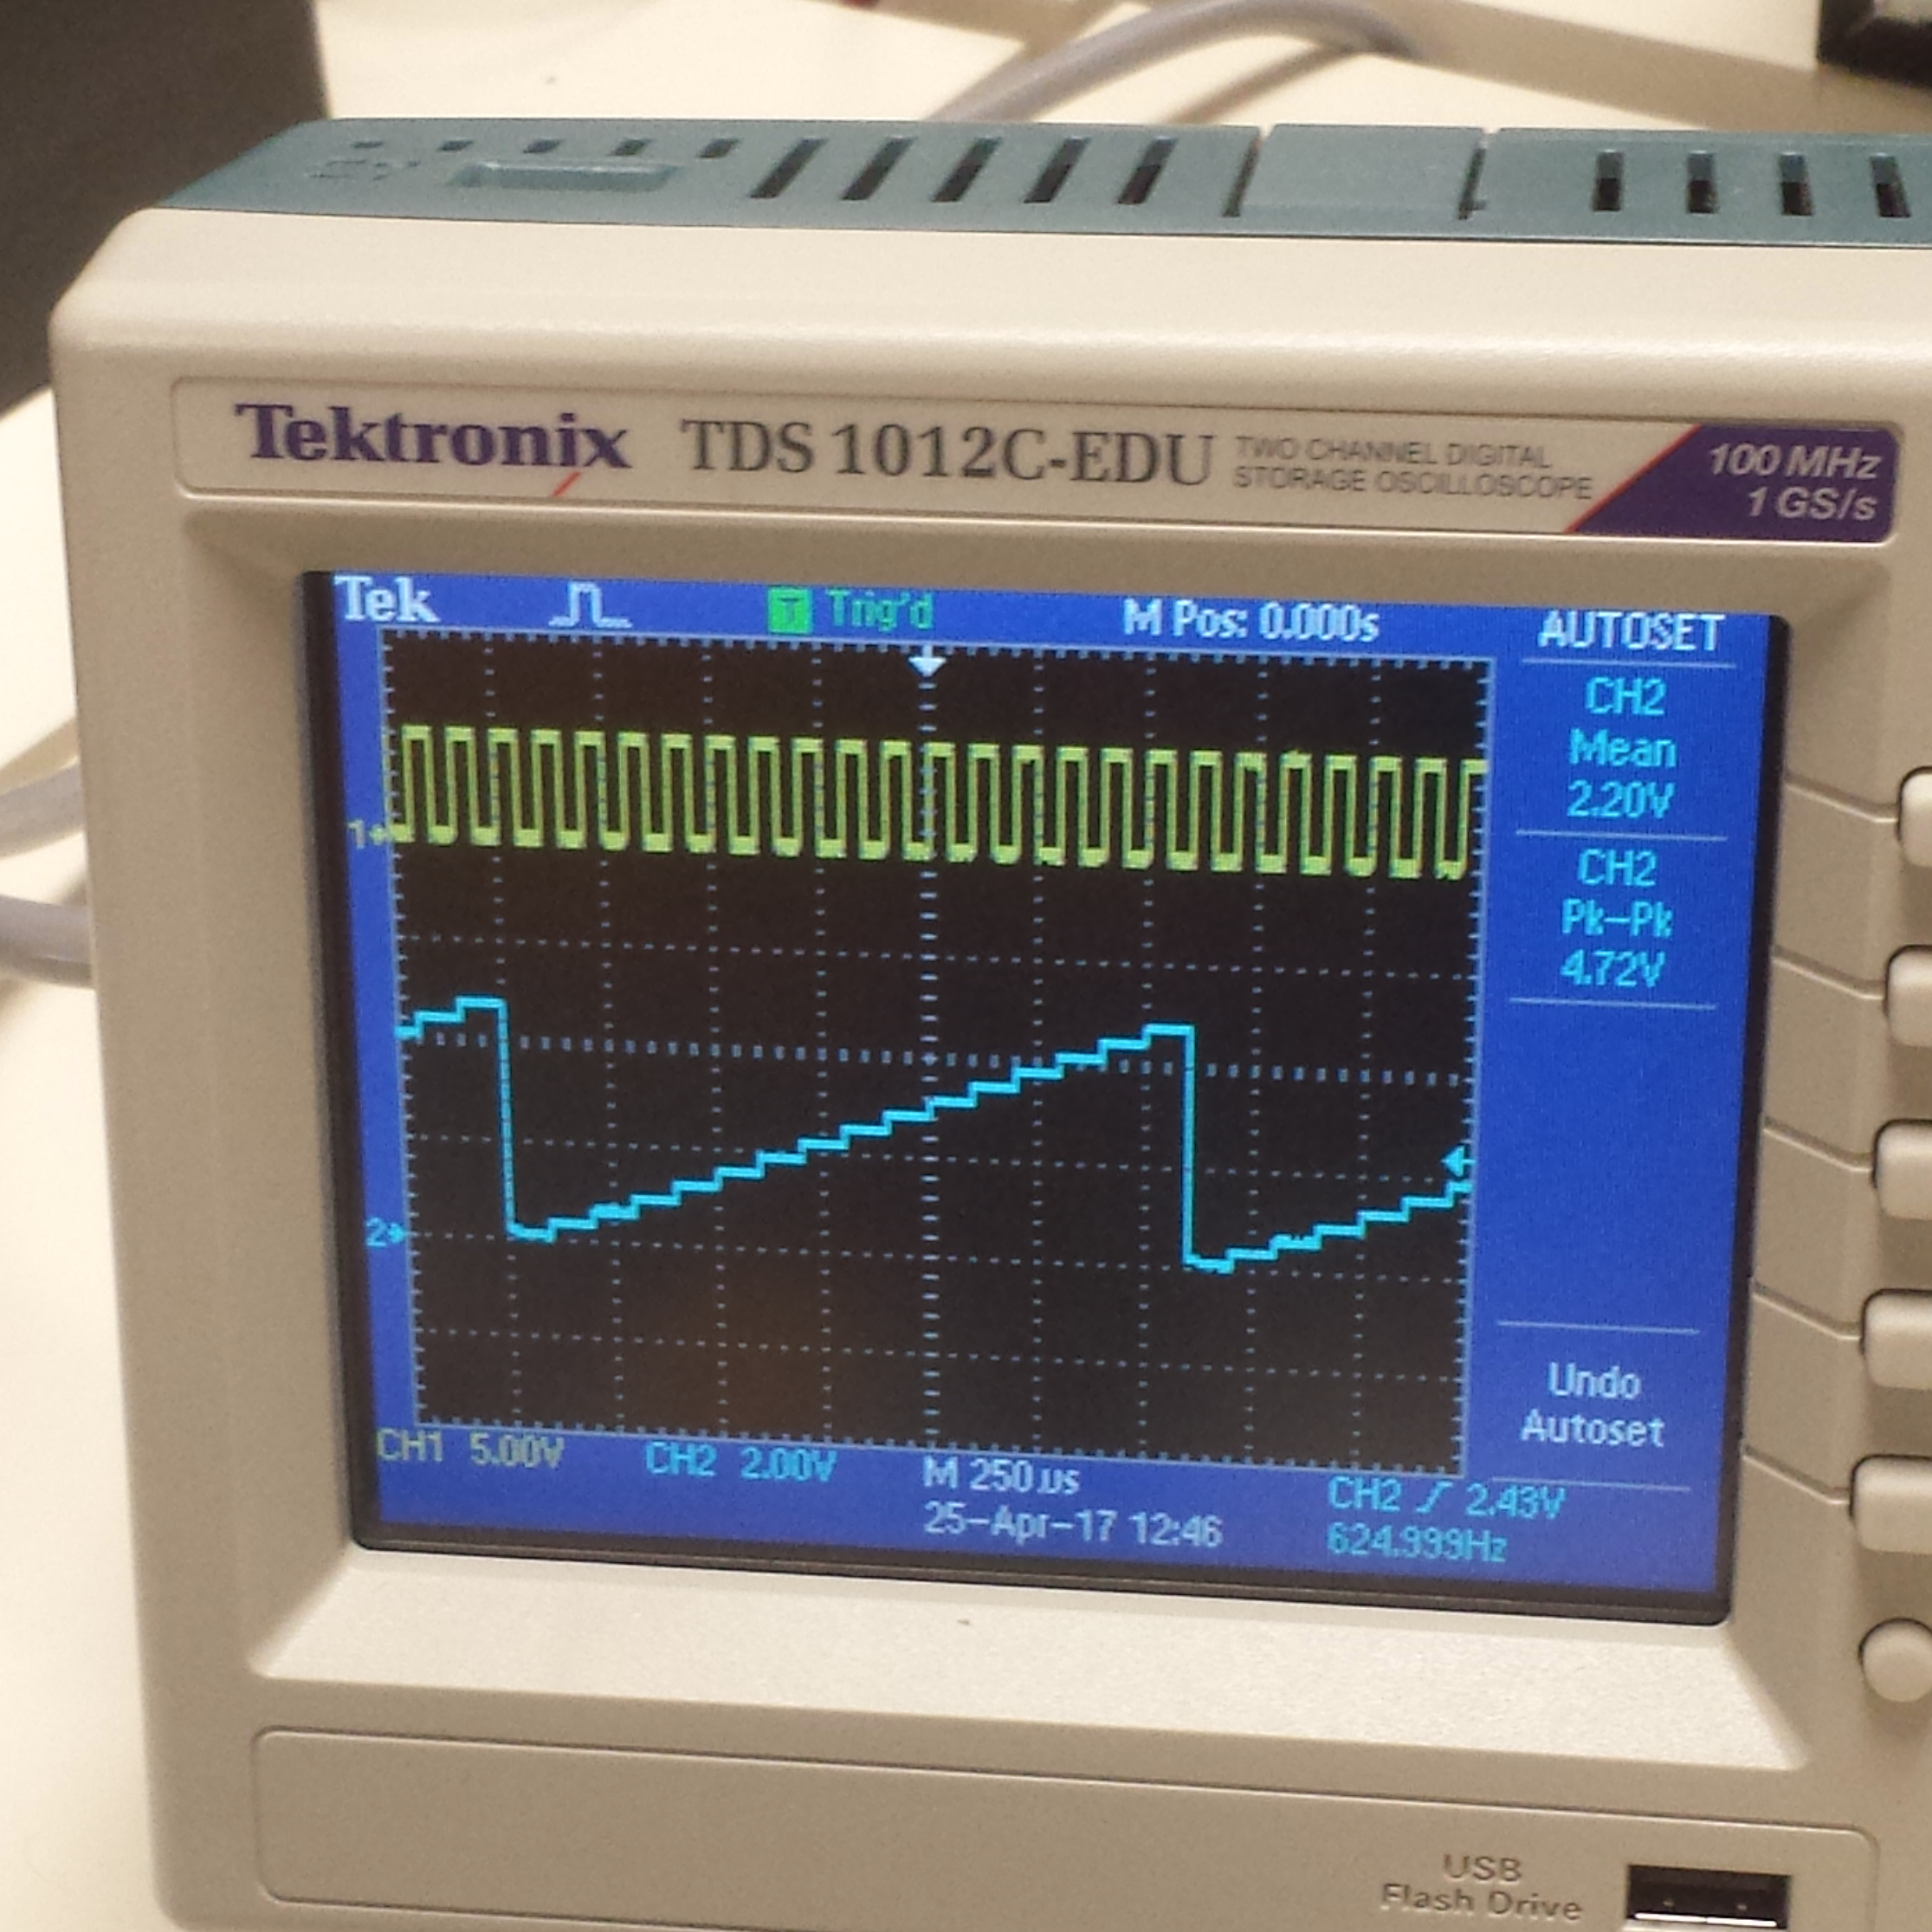

**Analysis**

Table 1. Frequency vs Pin number

|  |  |
| --- | --- |
| Pin number (Description) | Frequency |
| Pin 15 (Clock) | 10 kHz |
| Pin 6 (Q1) | 5 KHz |
| Pin 11 (Q2) | 2.5 KHz |
| Pin 14 (Q3) | 1.25 KHz |
| Pin 2 (Q4) | 0.625 KHz or 625 Hz |

Through building the ladder circuit, we found out that Pin 15 has twice frequency as Pin 6. Pin 6 has twice frequency as Pin 11. Pin 11 has twice frequency as Pin 14, and Pin 14 has twice frequency as Pin 2. In this circuitry, Pin 15 corresponds with the total voltage for V $analog$; Pin 6 corresponds with V $3$; Pin 11 corresponds with V $2$; Pin 14 corresponds with V $1$; Pin 2 corresponds with V $0$. The symmetry of the ladder circuit therefore proves a convergent power-serie of $\frac{1}{2}$ among the voltage elements: V $analog$, V3, V2, V1 and V0. If the symmetry of the circuit were broken, mathematically, the resistance in both parallel and series will change, so does voltage. Therefore, the expression of V $analog$ would also change. In this lab, we use a counter chip in our experiment. The counter chip is a chip that can count up or down in binary values incrementing or decrementing by 1 at a time. The counter chip is connected to a voltage source and supplies voltage for V $analog$, V3, V2, V1 and V0. Furthermore, the counter chip is a multi-channelled O-scope for digital signals. It only measures whether the signal is on or off, whereas the O-scope only measures V $analog$. The advantages of using a logic analyzer are that it can make many more channels than the O-scope, and can trigger on logical combinations of signals. When we change the voltage at pin 10 of the counter chip, we are able to know whether the counter chip is starting from 0 to 15 when we powered the source or from 15 to 0 when we connect to the ground. The V $analog$ directly relates to the V $analog$ of the signal. The binary 1 presents as the first step, and the binary 7 represents the seventh step. Thus the 15 digital inputs were displayed by specific voltage levels of Vanalog. Finally, the reason why increasing the frequency of the function generator changes the “staircase” shape of your output is because the clock speed (frequency) is very rapid and the counter chip counts incredibly rapidly, which could create a problem with either O-scope or the ability to read and measure the V $out$.

**Conclusion**

After completing this lab, we were able to successfully learn how to use a counter chip to power four separate power sources. The counter chip was used to facilitate the process of building this circuit with multiple voltage sources. Furthermore, this circuit is useful for converting digital signals into analog signals. These signals are used in products such as a digital camera to process information. During the experiment, some simple mistakes were made but it was easy to catch and fix. This experiment taught us a lot about using a counter chip to build a ladder network circuit. We also utilized the principle of parallel resistors to facilitate the process and to simplify our circuit design. In conclusion this experiment can be considered as a success because we were able to fully understand and analyze this circuit and its applications to the real world.